TAGORE DENTAL COLLEGE AND HOSPITAL
DEPARTMENT OF ORAL AND MAXILLOFACIAL SURGERY

GUEST LECTURE ON
“BLEEDING DISORDERS AND MANAGEMNT
IN DENTAL OFFICE”
DATE: 9.2.2021

Venue:
Conducted online through GOOGLE MEET application.

.

DEPARTMENT OF ORAL AND MAXILLOFACIAL SURGERY
TAGORE DENTAL COLLEGE AND HOSPITAL
MELAKOTTAIYUR POST, RATHINAMANGALAM
CHENNAI – 600127
PH: 044 – 3010 2222, EXTN: 228 / 230
EMAIL ID: maxfacs@tagoredch.in

PROF.M.MALA DR.CHITRAA R. CHANDRAN
CHAIRPERSON PRINCIPAL

ORGANIZING COMMITTEE:
PROF.DR.S.JIMSON
DR.ISRAEL NATHANAEL

ORGANIZER:
Department of Oral & Maxillofacial Surgery
Tagore Dental College & Hospital

Date: FEBRUARY 9, 2021

LEARNING OUTCOME:
To acquire detailed knowledge on bleeding disorders, pre-operative measures, precautions, intra operative measures, dental office management of bleeding disorder patients.

VENUE: Conducted online through official GOOGLE MEET application.

GUEST SPEAKERS:
- Dr.G. PADMANABA KUMAR
Adjunct Faculty At Tagore Dental College And Hospital
Department Of Oral and Maxillofacial Surgery
University Of Mahaya
Kuala lumpur, Malaysia.

MODERATOR :
1. Dr.ISRAEL NATHANAEL
Senior lecturer
Department of oral and maxillofacial surgery
Tagore dental college and hospital

TOPICS COVERED:
- Bleeding disorders
- Precautions in management of hemophilia cases
- Dental office considerations in bleeding disorder management

The guest lecture started with the welcome note by the Head of the Department, Prof.Dr.S.Jimson and the guest speaker was introduced by Dr.Israel Nathanael .the lecture session started sharply by 9.30. It was a detailed and very informative lecture on bleeding disorders, precautions, intra operative management of bleeding and management in the dental office.
The program was attended by85 students. The program received a good feedback from the participants.

GUEST LECTURE PICTURES:

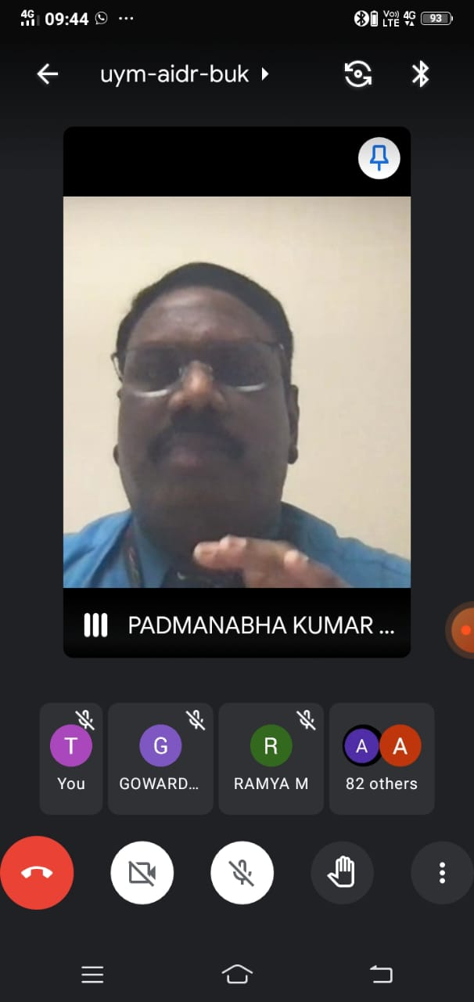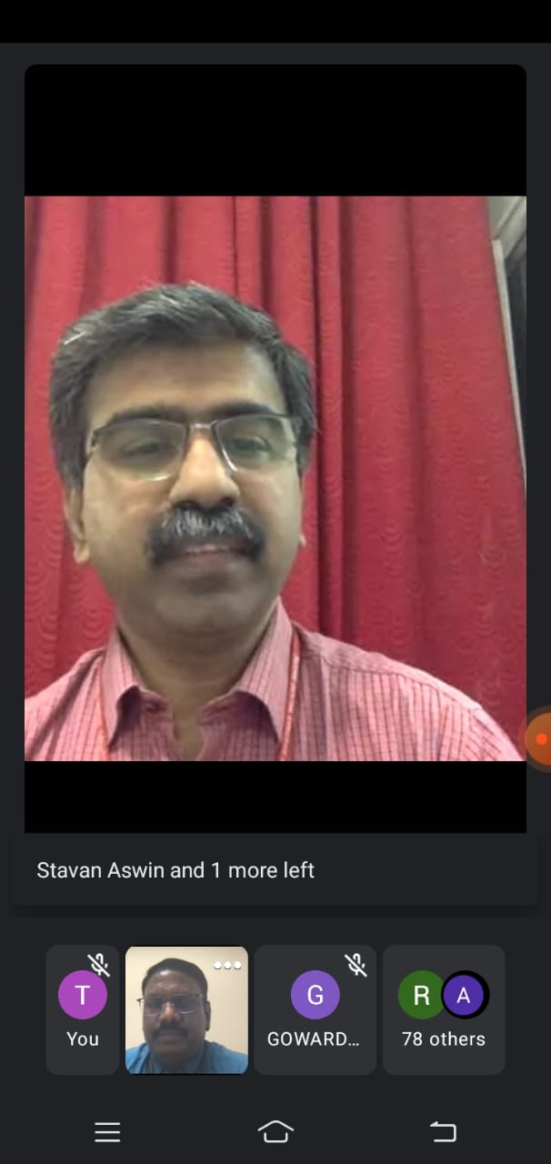
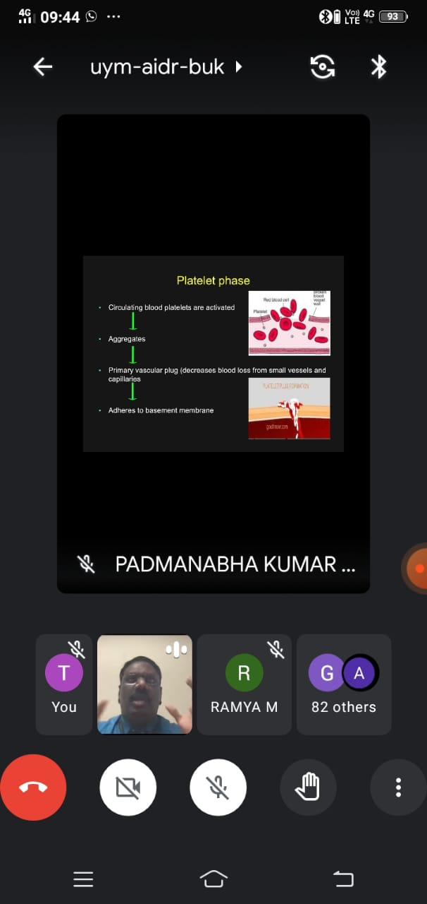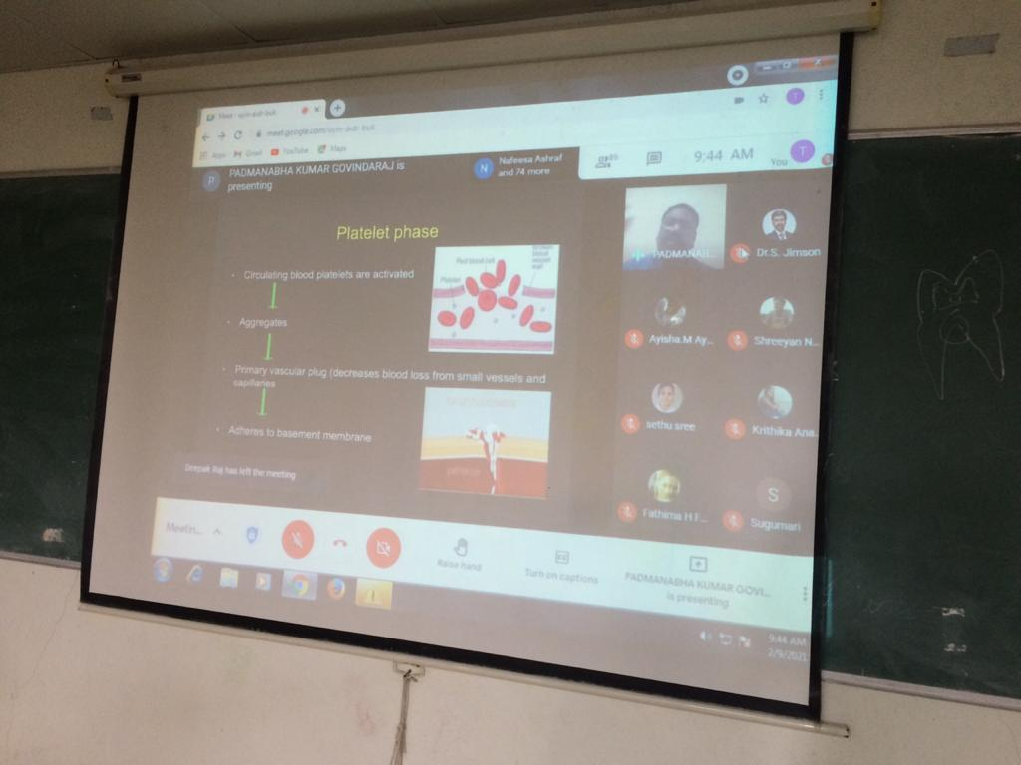

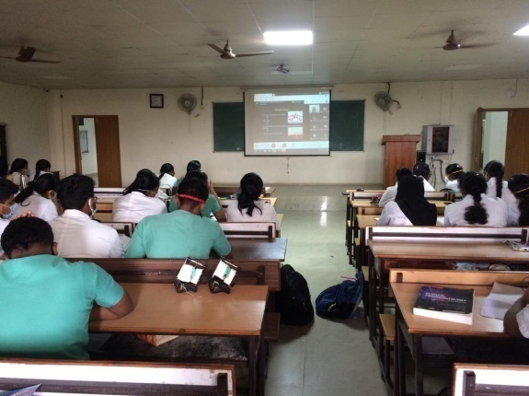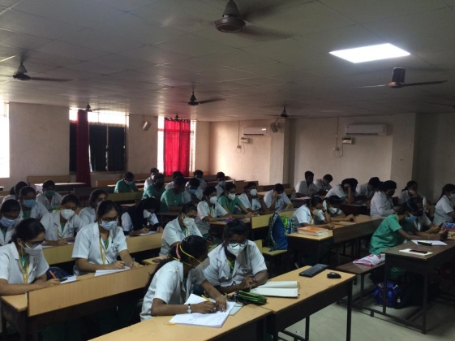

- AARTHI P
- AARUDRADEVI J G
- ABHITHA SHREE S
- AISHWARYA K
- AISHWARYA S
- AJAI KUMAR
- AJITH KUMAR S
- AKASH V
- AKSHAYA N
- ANITHA ROSELIN S
- ANJALI V
- ANUSIYA J
- ASHWINI D
- AYISHA M
- BAKYA LAKSHMI V
- BALAJI S A
- BHARANY MALAVIKA J
- BHARGAVI T
- BHAVANKUMAR V
- DEEPAK RAJ J
- DEEPIKA BARATHI M
- EZHIL BHARATHI I
- FATHIMA HASEEN FAZEENA
- GOKULA PRIYA R
- GAYATRI
- GOPINATH B
- GOWARDHAN S
- HARITHA R
- JANANEE BHARKAVI N
- JANISHA M
- JEBASELVI P
- JEYAMITHA R
- KALKI PRIYA A
- KALPITA DEB BARMAN
- KAMIL HANEEF
- KANMANI
- KARTHIKEYAN A
- KRISHNA PRIYA
- KRITHIKA A
- LAKSHAYA
- MALARVIZHI G
- MARIA SELVA VIVETHA A
- MONISHA N C
- MUTHU MEENAL M
- NAFEESA
- NIRMALA S
- NISHA DAPHNE R
- NISHAALI M.M
- PAVITHRA M
- POOJA DHARSHINI R
PARTICIPANTS
- PRAVINA
- PREETHA J H
- PRIYA S
- PUVITHA A
- RAGAPRIYA
- RAJ SHREE E
- RAKSHNA N
- RAMYA M
- RESHMA S
- RITHIKA SRI S
- SAROJINI
- SETHU SREE G
- SHARMILA E
- SHREEYAN NAYAR M N
- SHRIKAVI M
- SHREELAKSHMI
- SIVARANJANI S
- SRIDEVI S
- SRIJANANI S
- STAVAN V
- SUBASH B
- SUBASH M
- SUGUMARI
- SUMAIYA B
- SUMAIYA FATHIMA T
- SUNIL KUMAR
- SUTHAMANCHARRI S
- THILAKRAJ S
- VASANTHAN R M
- VETHIKA K
- VIVETHA
- YOGESH PERIYASWAMY
- AVINASH MOORTHI
- DIWAKAR
- SUDESH

STAFFS
1. Dr.S.Jimson
2. Dr.Israel Nathanael

